Nguyen Le Nhat Duong - 1952638

Le Duc Cam - 1952588

Tran Anh Thai - 1752494

**Question 1:**

a)(a - b - c) / d & (e * f * g - 3)

a1

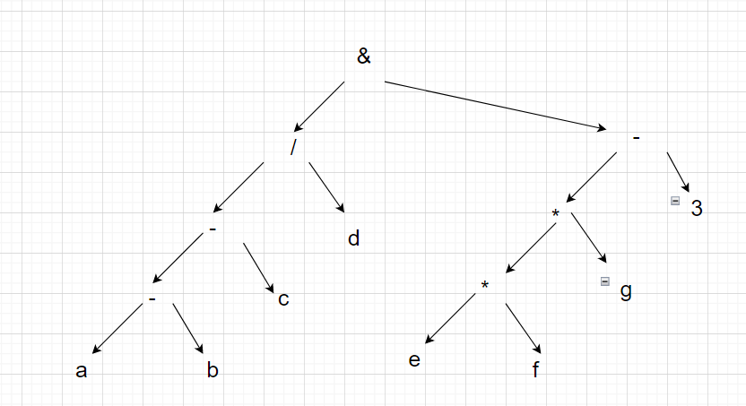

Polish prefix: &/--abcd-**efg3

Cambridge Polish prefix :(& (/ (- a b c) d)(- (* e f g) 3))

Polish postfix: a b - c - d / e f * g * 3 - &

A2 a > b xor c or d <= 17

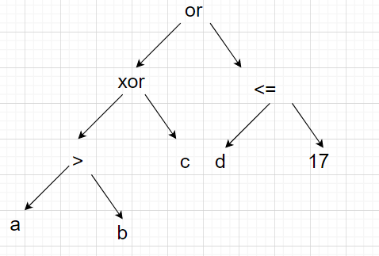

Polish prefix: or xor > a b c <= d 17

Cambridge Polish prefix: (or (xor (> a b) c) (<= d 17))

Polish postfix: a b > c xor d 17 <= or

b) + c)

**A1 : (a - b - c) / d & (e *f *g - 3)**

Polish prefix: &/--abcd-**efg3

Cambridge Polish prefix :(& (/(-abc)d)(-(*efg)3))

Polish postfix: a b - c - d / e f * g * 3 - &

**A2: a > b xor c or d <= 17**

Polish prefix: or xor > abc <= d 17

Cambridge Polish prefix: (or(xor(>ab)c)(<=d 17))

Polish postfix: a b > c xor d 17 <= or

d)

Xor or a b and >= c d = e f

e = f and c>=d xor (a or b)

**Question 2:**

**Next, if $a$ is greater than $0$ and $\sqrt{a}>b$ then assign $1$ to variable $c$; otherwise if $a$ equals $0$ or $b / a$ is greater than $1$ then assign $2$ to $c$.**

if a > 0

if sqrt(a) > b

c = 1

elif a == 0:

c = 2

elif b/a == 0:

c = 2

**Question 3:**

The possible values are:

6 6 6 | 10 6 6 | 6 6 10 | 10 6 10

6 + 6*6= 42

10 + 6*6= 46

6 + 6*10= 66

10 + 6 * 10 = 70

Cao Bá Huy - 1952713

Quách Đằng Giang - 1952044

Nguyễn Luật Gia Khôi - 1952079

**Question 1:**

**a1)**

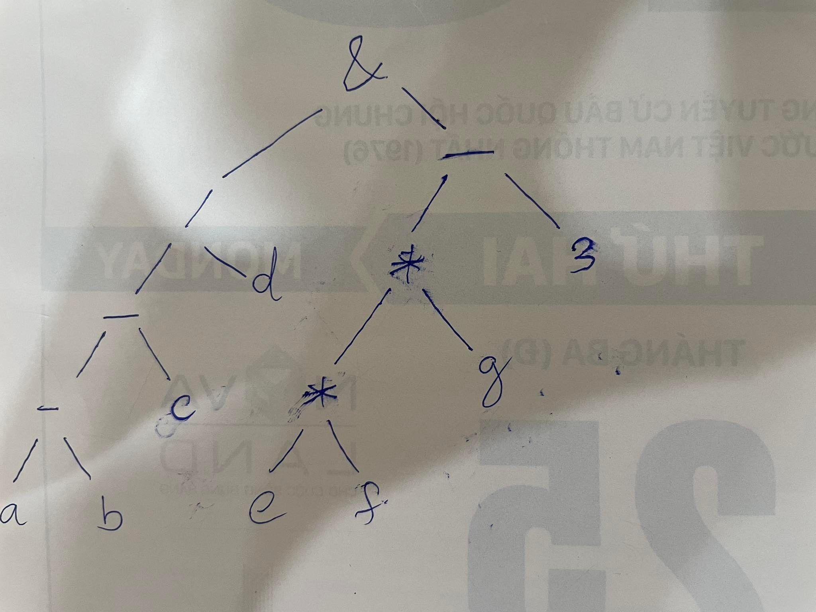

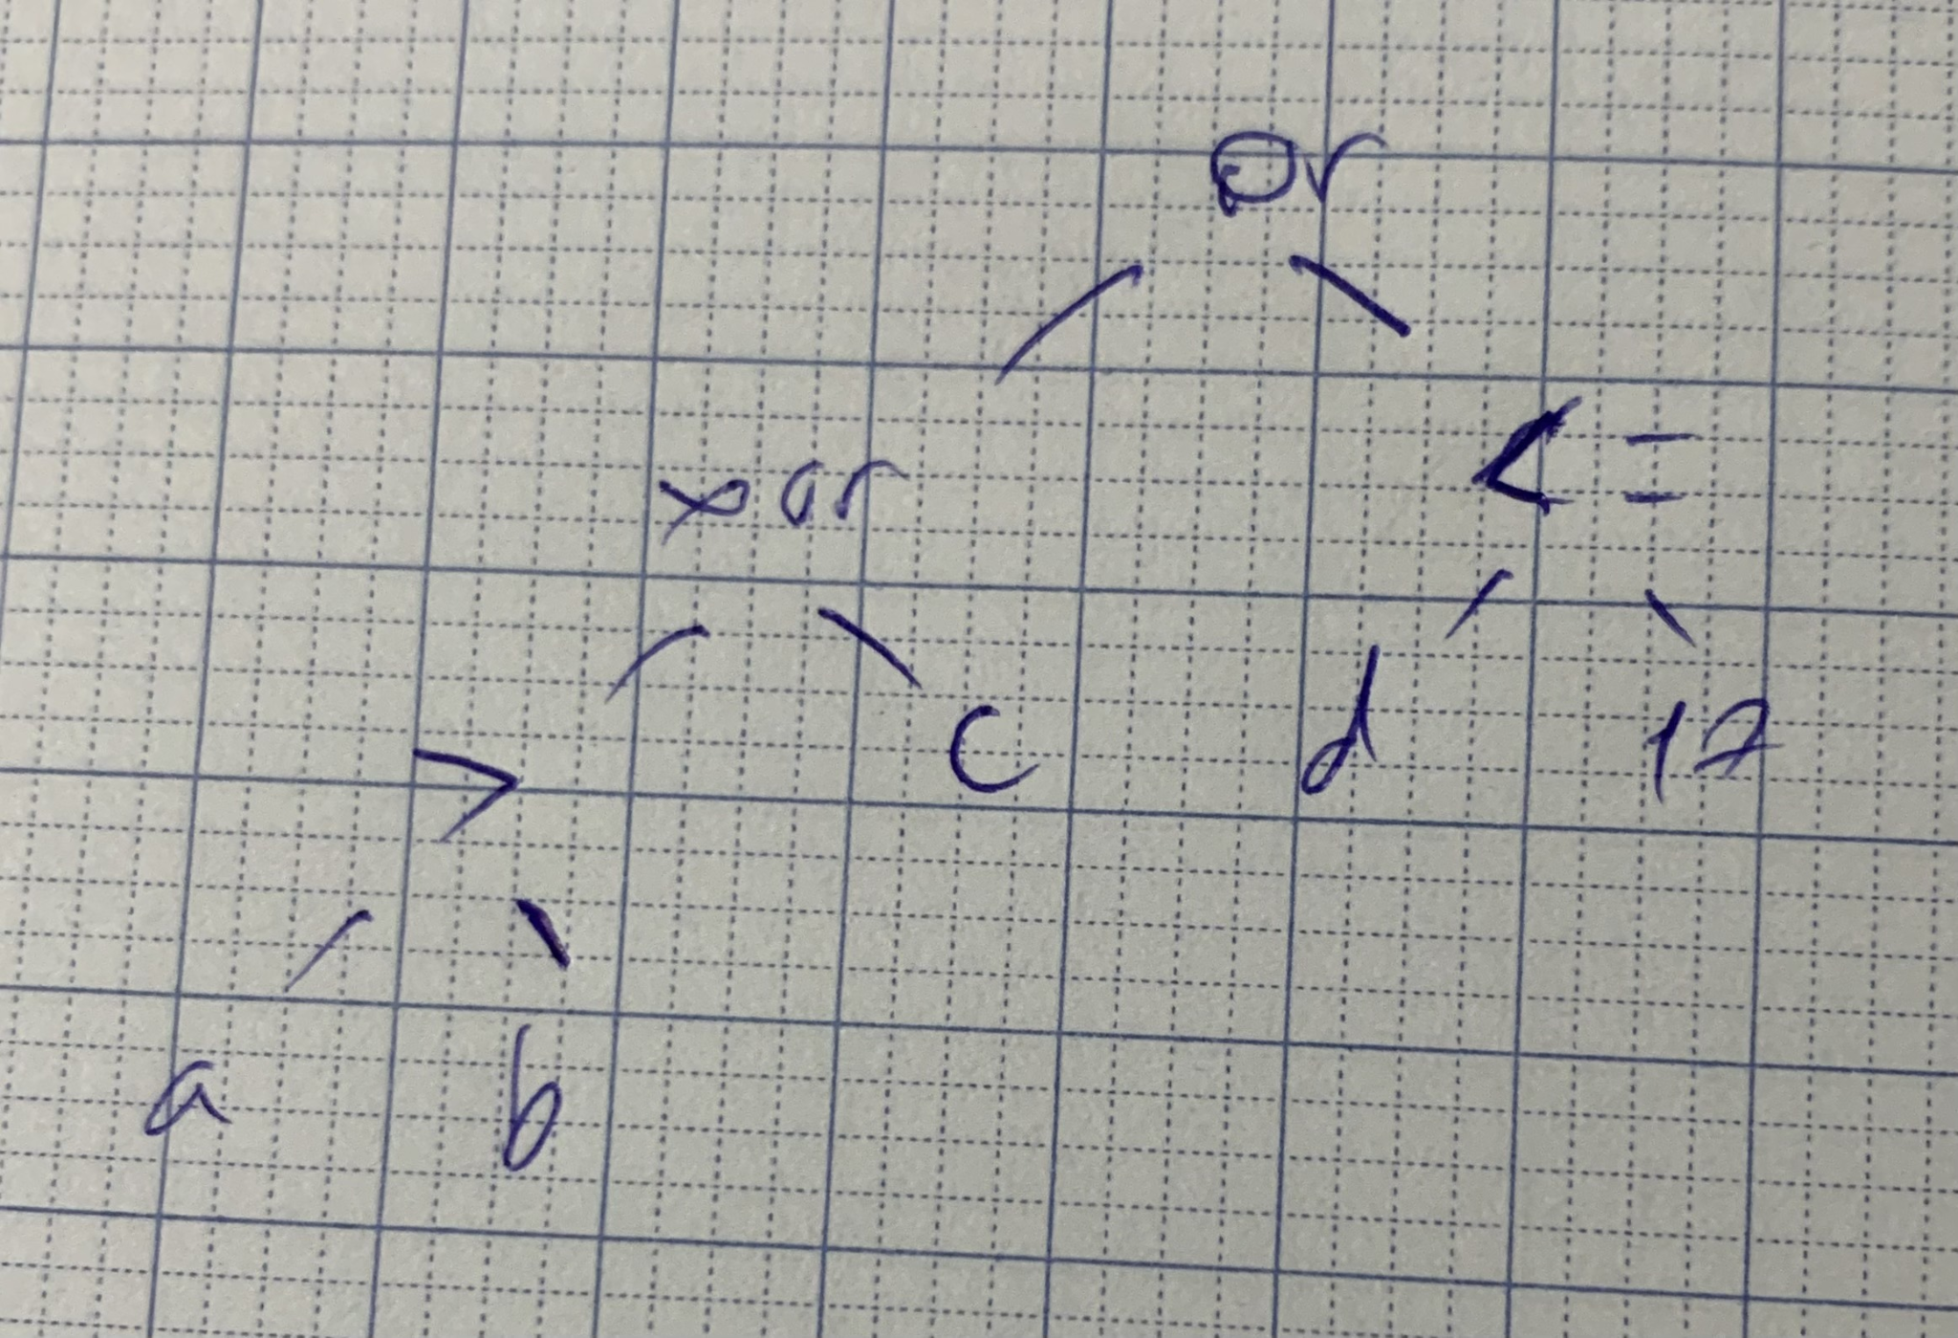

**b)**

a1 Prefix: &/--abcd-**efg3

a1 Postfix: ab-c-d/ef*g*3-&

a2 Prefix: or xor > a b c <= d 17

a2 Postfix: a b > c xor d 17 <= or

**c1**

(& (/ (- a b c) d)(- (* e f g)3))

**c2**

(or (xor (> a b) c) (<= d 17))

**d)**

a or b xor c >= d and e = f

**Question 2:**

if(a > 0) :

if (sqrt(a) > b) :

c = 1

elif (b/a > 1):

c = 2

elif(a == 0 ) :

c = 2

elif (b/a > 1) :

c = 2

**Question 3:**

a + (a = 6)* a

***Ans :***

10 + 6*10 = 70

10 + 6*6 = 46

6 + 6*6 = 42

6 + 6*10 = 66

Nguyễn Minh Tâm - 1952968

Đỗ Đăng Khoa - 1952295

Phạm Nhựt Huy - 1952059

Question 1:

a1)

(a - b - c) / d & (e * f * g - 3)

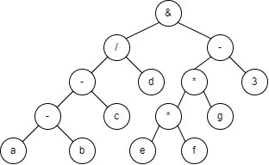

a2)

a > b xor c or d <= 17

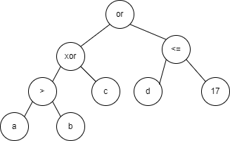

b)

a1) Polish prefix: & / - - a b c d - * * e f g 3

Polish postfix: a b - c - d / e f * g * 3 - &

a2) Polish prefix: or xor > a b c <= d 17

Polish postfix: a b > c xor d 17 <= or

c)

a1) Cambridge Polish prefix: (& (/ (- a b c) d) (- (* e f g) 3))

a2) Cambridge Polish prefix: (or (xor (> a b) c) (<= d 17))

d)

Prefix: xor or a b and >= c d = e f

=> Infix: a or b xor c >= d and e = f

Question 2:

if (a > 0):

if (sqrt(a) > b):

c = 1

elif (b / a > 1):

c = 2

else:

if (a == 0):

c = 2

elif (b / a > 1):

c = 2

Question 3:

a = 10

a + (a = 6) * a

Case 1: 10 + 6 * 10 = 70 // + operator evaluates left operand first, * operator evaluates right operand first

Case 2: 10 + 6 * 6 = 46 // + operator evaluates left operand first, * operator evaluates left operand first

Case 3: 6 + 6 * 10 = 66 // + operator evaluates right operand first, * operator evaluates right operand first

Case 4: 6 + 6 * 6 = 42 // + operator evaluates right operand first, * operator evaluates left operand first

=> Possible values: 42, 46, 66, 70

Lê Minh Khôi - 1952076

Bùi Quang Tiến - 1953018

Lâm Minh Quân - 1952114

**1)**  a1)

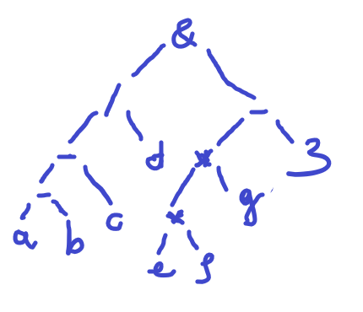

a2)

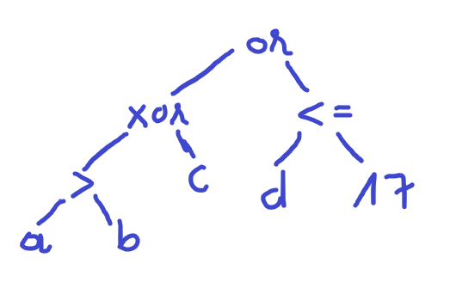

b) Polish prefix : a1: &/--abcd-**efg3

a2: **or** **xor** **>**abc **<=**d17

Polish postfix: a1: ab-c–d/ ef*g*3-&

a2: ab**>** c **xor** d 17 **<=** **or**

c) Cambridge Polish Prefix: a1: (& (/ (- a b c) d) (- (* e f g) 3))

a2: (or (xor (> a b) c) (<= d 17))

d) Prefix: xor or a b and >= cd = ef

Infix: a or b xor c >= d and e = f

**2)**

flag = 0

if a > 0:

if sqrt(a) > b:

flag = 1

c = 1

if flag == 0

if a == 0:

c = 2

elif b / a > 1:

c = 2

**3)** a + (a = 6) * a

10 + 6 * 10 = 70

6 + 6 * 6 = 42

10 + 6 * 6 = 46

6 + 6 * 10 = 66

Võ Ngọc Sang - 1952430

Lương Duy Hưng -1952747

Bùi Hoàng Phúc - 1952925

**Question 1)**

a1)

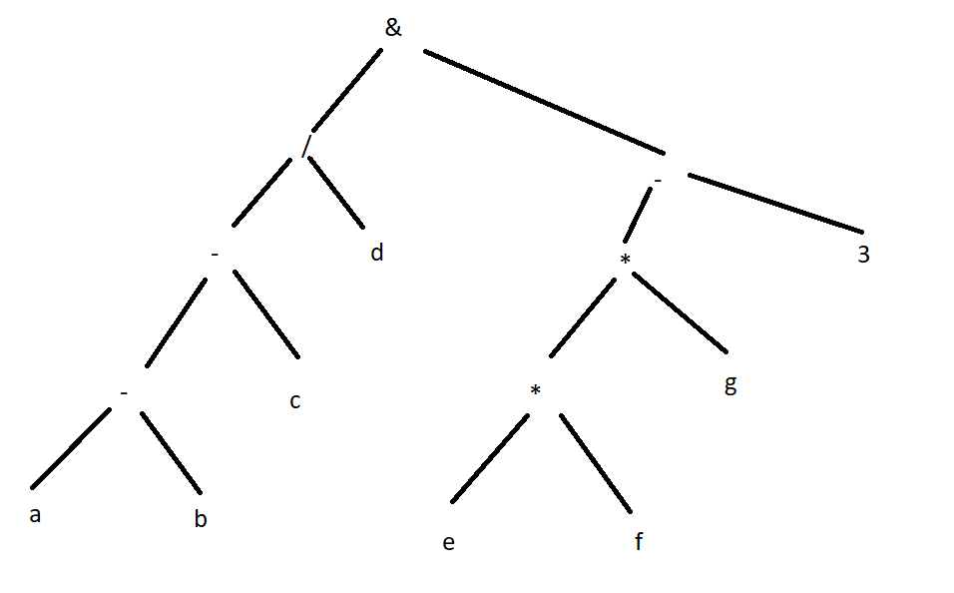

a2)

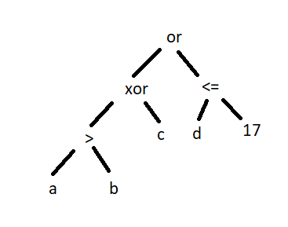

b)

b1)

Prefix: & / - - a b c d - * * e f g 3

Postfix: a b - c - d / e f * g * 3 - &

b2)

Prefix: or xor > a b c <= d 17

Postfix: a b > c xor d 17 <= or

c)

c1)

Cambridge Prefix: (&(/(-abc)d)(-(*efg)3))

c2)

Cambridge Prefix: (xor(>ab)c(<=d17))

d)

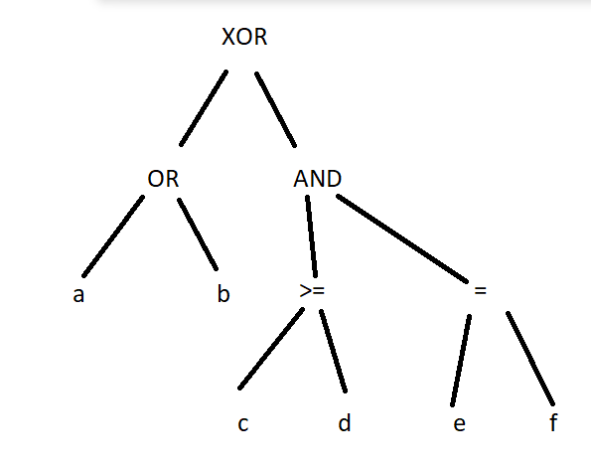

Polish infix: a or b xor c >= d and e = f

**Question 2)**

int main()

{

int c = 0;

int a, b;

cin >>a >>b;

if (a>0)

{

if (sqrt(a)>b){

c=1;

}

}

else if (a==0){

c=2;

}

else if (b/a > 1){

c=2;

}

}

**Question 3)**

10 + 6 * 10 = 70

10 + 6 * 6 = 46

6 + 6 * 10 = 66

6 + 6 * 6 = 42

Huỳnh Minh Trí - 1953041

Mai Tôn Nhật Khánh - 1852038

a)

**&**

/ \

**/** **-**

/ \ / \

**-** **d** **\*** **3**

/ \ / \

**-** **c** **\*** **g**

/ \ / \

**a** **b**  **e** **f**

A2.

**or**

/ \

**xor <=**

**/ \ / \**

**> c d 17**

**/ \**

**a b**

b)

a1.

Polish prefix: NLR

**& / -- a b c d - * * e f g 3**

Polish postfix: LRN

**a b - c - d / e f * g * 3 - &**

a2.

Polish prefix: NLR

**or xor > a b c <= d 17**

Polish postfix: LRN

**a b > c xor d 17 <= or**

c)

a1.

**(& (/ (- a b c) d) (- (* e f g) 3))**

a2.

**(or (xor (> a b) c) (<= d 17))**

d) xor or a b and >= cd = ef

**a or b xor c>=d and e=f**

Q2.

Input a,b

If a > 0

then if sqrt(a) > b

then c := 1

else

If a = 0

then c := 2

If a != 0

then if b /a > 1

then c := 2

Q3. (a = 10)

a + (a = 6) * a

**10 + 6 * 6 = 46**

**10 + 6 * 10 = 70**

**6 + 6 * 10 = 66**

**6 + 6 * 6 = 42**

**Phạm Bùi Minh Huân - 1952056**

**Phạm Khánh Trình - 1953044**

**Ho Trí Kháng - 1952069**

**Question 1:**

**a.1)**



**(a - b - c) / d & (e * f * g - 3)**

**Polish prefix:** & / - - a b c d - * * e f g 3

**Polish postfix:** a b - c - d / e f * g * 3 - &

**Cambridge Polish prefix:** (& (/ (-abc) d) ( - (*efg) 3))

**a.2)**



**a > b xor c or d <= 17**

**Polish prefix:** or xor > a b c <= d 17

**Polish postfix:** a b > c xor d 17 <= or

**Cambridge Polish prefix:** (or (xor (> a b) c) (<= d 17))

**d)**

**Polish prefix: xor or a b and >= c d = e f**

**Polish infix:** a or b xor c >= d and e = f